Lab 02
Objectives:

This lab will enable students to:
  - Learn top down and bottom up design methodologies
  - Data flow level modeling

TASK 1:
4 bit Ripple Carry Adder

Block Diagram:

Following is the block diagram of a 4 bit Ripple Carry Adder.

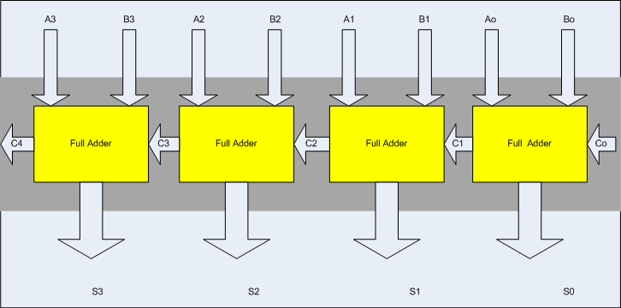

Steps for task 1a:

The following steps should be performed while designing a 4 bit RCA adder

ModelSim:

- First implement a Full adder using data gate level modeling.
- Simulate the Full adder with a test bench.
- Instantiate the Full adder four times and connect the circuit as shown.
- Now again write a test bench and simulate the 4 bit RCA.

Task 1b:
Design the 4 bit full adder using data flow level modeling.

